Syllabus
Certified NIS2 Professional (CNIS2)

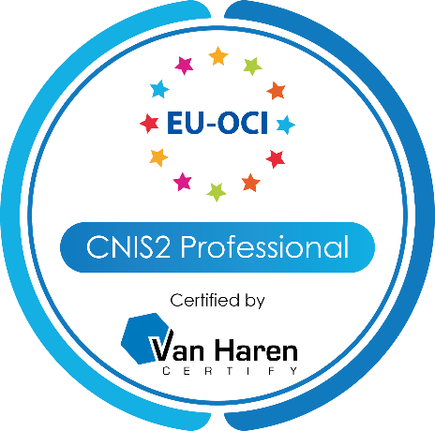

Version 1.0

All rights reserved. No part of this publication may be reproduced, distributed, stored in a data processing system, or published in any form by print, photocopy, or any other means whatsoever without the prior written consent of the authors and publisher.
This material contains diagrams and text information based upon:
The NIS2 Navigator’s Handbook: Bridging the Cybersecurity Gap ©Van Haren Publishing
All other brands, companies, and product names are used for identification purposes only and may be trademarks that are the sole property of their respective owners.

About Certified NIS2 Professional (CNIS2)
As cyber risk concerns are becoming increasingly prominent in the risk profiles of organizations, members of senior management bodies are required to understand these risks and make informed decisions for the organization that consider these risks and their impact, not just on the organization itself, but also on the ultimate recipients of their products and services.
IP owner:
Accreditation institute:
Examination institute:
EU Organisational Compliance Institute
Van Haren Certify
certN

The Network and Information Systems Directive released in 2022 (NIS2 Directive) emphasizes the importance of this understanding and involvement by these members of the organization’s management bodies by requiring them to actively involve themselves in cybersecurity risk management and the implementation of measures to make these risks justifiably acceptable.
Navigating NIS2: Bridging the Cybersecurity GAP takes you on tour through the NIS2 Directive. It is a tour for these members of the organization’s management bodies, whether they are the Chief Information Security Officers, Chief Risk Officers, Chief Executive Officers, or any other member of the management team. This course is unique because it understands that, especially for these members, time is a precious commodity. Hence, this course walks you through the overall Directive in the first day and takes you through a NIS2 assessment of your own organization on the second day. As attendee, you will not only complete the tour with an understanding of what the NIS2 means, but specifically what it means to you and what you should do to become compliant.

Certification definition
The CNIS2 certification validates a candidate’s understanding of the Directive including the measures that it prescribes. The certification also verifies the candidate’s knowledge about basic information security concepts that enable the candidate to discuss the cybersecurity risk management measures with those that are charged to implement and maintain them.

Certification definition
Candidates can become certified by passing the Certified NIS2 Professional exam.
Vouchers for the certification exam are available through accredited trainers and Van Haren Group.

Certification renewal
The CNIS2 Professional certificate is valid indefinitely.

The certificate you receive after passing the exam shows the date of issue. It also indicates how long the certificate is valid.

Exam format
The general exam regulations apply to this exam.

Attemps per voucher: | 1
Number of questions: | 40
Passing score: | 60%
Passing score for trainers: | 75%
Time: | 60 min.
Open book: | No
Language: | Engels
Invigilation: | Yes
Question type: | multiple choice

Exam syllabus

The following table is an overview of the topics examined in the certification exam.

Module | Exam Requirements | Exam Specification | Bloom  level | Weight % | Book | Courseware
1 | Background |  |  | 10%
1.1 |  | Cybersecurity in the Union | 1 |  | Ch 2.1-2.4 | Ch 1.1
1.2 |  | EU cybersecurity strategies and programs |  |  | Ch 2.2 | Ch 1.2-1.5
1.3 |  | EU Regulatory Framework |  |  | Ch 2.4.2 | Ch 1.6
2 | Directive structure |  |  | 15%
2.1 |  | NIS Directive | 1 |  | Ch 2.2.3, 2.5 | Ch 2.1
2.2 |  | NIS2 Scoping | 1 |  | Ch 3.6-3.7 | Ch 2.2-2.3
2.3 |  | NIS2 Structure |  |  | Ch 3.1, 3.3 | Ch 2.4
2.4 |  | NIS2 bodies and institutions |  |  | Ch 3.5 | Ch 4
3 | Entity roles, responsibilities, and obligations |  |  | 15%
3.1 |  | Roles and responsibilities | 1 + 2 |  | Ch 3.10 | Ch 6
3.2 |  | Entity requirements | 1 |  | Ch 3.8 | Ch 5.1-5.4
3.3 |  | Supervision and enforcement |  |  | Ch 3.9 | Ch 5.5
4 | Security concepts |  |  | 10%
4.1 |  | Basic security concepts | 2 |  | Ch 3.4 | Ch 3
5 | Cybersecurity risk-management measures |  |  | 30%
5.1 |  | Cybersecurity program | 1 |  | Ch 4.1 | Ch 7.1
5.2 |  | Risk management | 1 |  | Ch 4.3 | Ch 7.2
6 | Implementation |  |  | 20%
6.1 |  | Implementing measures |  |  | Ch 4.2, 4.4-4.8 | Ch 7.3-7.15
6.2 |  | Reporting to the management body |  |  | Ch 3.8.2, 3.10.1, 3.10.2

* More information about the levels of cognition click here

Reference Material
The reference material for the Certified NIS2 Professional exam is:
- The NIS2 Navigator’s Handbook: Bridging the Cybersecurity Gap
- Author: Michiel Benda
- Publisher: Van Haren Publishing

Trainer accreditation
Van Haren Learning Solutions organizes the trainer accreditation for this certification program. More information on the accreditation process can be found on their website.

